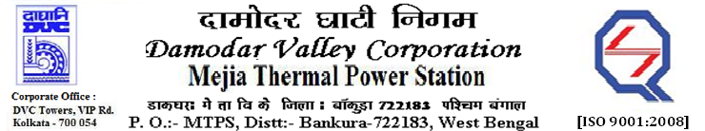
Phone No.: 03241- 263038 FAX: 03241-262287

E-Tender Notice

Damodar Valley Corporation invites online bids with On-line reverse auction (RA) from eligible bidders for:

 | NIT No. | Description of Job (s) | Tender Downloading Period & Time
1. | GeM Bid No. GEM/2023/B/3520248 Dated: 08-06-2023  (DVC NIT NO. MT/O&M/QSF-05-06-16/23-24/DBN (13) HQ C&M/ GEM/2023/B/3520248/266 Dated 08/06/2023) | Annual Rate Contract for Operation & Maintenance assistance for Chlorination plant of cooling water system and Water treatment plant of U#1-6, MTPS, DVC for 02 (two) years i.e. 730 days | From 19:41 PM of 08.06.2023 to  11:00 AM of 22.06.2023

For further details and to participate in the tender, please log on to DVC Website www.dvc.gov.in, and https://gem.gov.in/

Your faithfully,

Sd/-

Sri Gour Chandra Ray,
Sr. Manager (C&I), C&M Dept., MTPS, DVC,
[gour.roy@dvc.gov.in],
Mob: 9434745711

