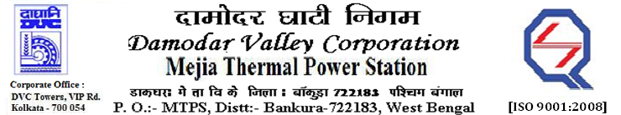
Phone No.: 03241- 263038 FAX: 03241-262287

E-Tender Notices

Damodar Valley Corporation invites online bids with On-line reverse auction (RA) from eligible bidders for:

 | NIT No. | Description of Job (s) | Tender Downloading Period & Time
1. | MT/O&M/QSF-05-06-02/23-24/GEM/2023/B/3386453/SN(034)/252 | Proposal for 'Engagement of welding Expert (WRI-Ex BHEL) for supervision work of HP Welding & related process during overhauling of Boiler of any Three nos. units of MTPS #1 to 6 | From 11.45 Hrs. of 13.05.2023 to 10.00 Hrs. of 10.06.2023.

For further details and to participate in the tender, please log on to DVC Website www.dvc.gov.in, and https://etenders.gov.in/eprocure/app
Note: e-procurement Helpdesk No. 9831683690 / Mob: 8240124812 may please be contacted.

Your faith fully,

Sd/-

Mr. Sumanta Mondal,
SE (Tech), MTPS, DVC, [sumanta.mondal@dvc.gov.in],
Mob: 9434746047

