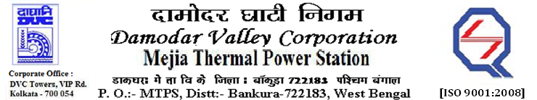
Phone No.: 03241- 263038 FAX: 03241-262287

E-Tender Notice

Damodar Valley Corporation invites online bids with On-line reverse auction (RA) from eligible bidders for:

 | NIT No. | Description of Job (s) | Tender Downloading Period & Time
1. | GeM Bid No. GEM/2023/B/3301440 Dated : 28-03-2023 | Annual Rate Contract for Generator and Excitation system, Protection panels, Control Desk/Panels, DG Sets Generator Bus duct, HT Bus duct, Battery, Chargers, Actuators, Plant illumination, Electrical Laboratory etc. of MTPS Unit #7&8 (2×500MW). | From 17:14 PM of 28.03.2023 to  11:00 AM of 25.04.2023
2. | GeM Bid No. GEM/2023/B/3309892 Dated: 31-03-2023 | Annual Rate contract (ARC) for maintenance of HT & LT Switch Gear, HT& LT Motors, HT& LT Cables, LT Bus Duct, Distribution Transformers etc. under BTG, entire Ash package, Plant Water system including Barrage Intake and BOP area excluding electrical equipment/system under the scope of ESP, Switchyard and CHP area of U#7&8, MTPS for two (02) years. | From 19:30 PM of 31.03.2023 to  11:00 AM of 28.04.2023
3. | GeM Bid No. GEM/2023/B/3314364 Dated: 31-03-2023 | Annual Rate Contract (ARC) for Fire Detection System of Unit#7&8, MTPS for a period of 02(Two) years. | From 12:04 PM of 31.03.2023 to  11:00 AM of 15.04.2023

For further details and to participate in the tender, please log on to DVC Website www.dvc.gov.in, and https://gem.gov.in/

Your faithfully,

Sd/-

Sri Anand Prakash Lal,
SE (C&M), Works, MTPS, DVC,
[anand.lal@dvc.gov.in],
Mob: 9434745809

