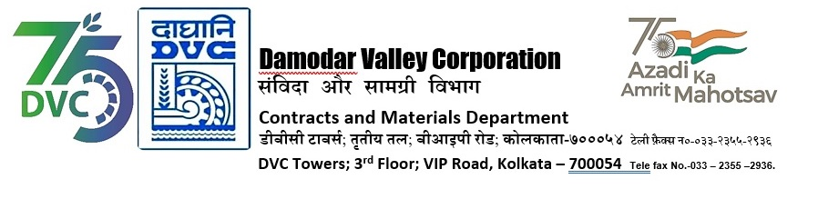

|  |  |  |
| --- | --- | --- |
| **DAMODAR VALLEY CORPORATION**  **Contracts and Materials Department**  **DVC Towers; 3rd Floor; VIP Road, Kolkata – 700054**  **Tele fax No.-033 – 2355 –2936.** | | |
|  | | |
| **E-TENDER NOTICE**  **“THROUGH GeM PORTAL ONLY”**   |  |  |  | | --- | --- | --- | | **Sl. No.** | **NIT No. & Description of Work** | **Tender Downloading Time & Period** | | 1. | **GeMBid No. :**  GEM/2024/B/5183983 Dated: 19-07-2024  **Tender Description :**  lifting of 5.0 (Five) LMT coal from NLC India Limited (NLCIL)- Talabira II & III OCP, Sambalpur, Odisha to DSTPS and other TPS of DVC in RCR mode. | From **20/07/2024 at 17:00 Hrs. (IST) to 05-08-2024 12:00 Hrs. (IST)** | | For further details and participate in the tender, please log https://gem.gov.in/  or www.dvc.gov.in [For view only]  for any help regarding the above tender contact to  GeM Customer care at <https://gem.gov.in/contactUs> | | | | | |
|  |