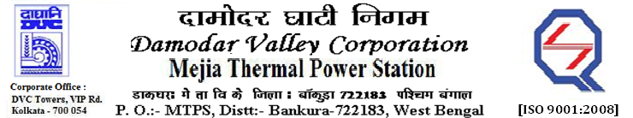
Phone No.: 03241- 263038 FAX: 03241-262287

E-Tender Notices

Damodar Valley Corporation invites online bids with On-line reverse auction (RA) from eligible bidders for:

 | NIT No. | Description of Job (s) | Tender Downloading Period & Time
1. | MT/O&M/QSF-05-06-01/22-23/GEM/2023/B/3307751/SN(035)/223 | ARC for Mechanical Maintenance, Upkeepment & Equipment Cleaning of Coal Mills & its Auxiliaries including Coal Feeders, PA Fans, Seal Air Fans, Purge Air Fans and all the associated Ducts, Dampers, Gates, PF Pipings etc. of U#1-4, MTPS. | From 19.24 Hrs. of 05.04.2023 to 11.00 Hrs. of 20.04.2023.

For further details and to participate in the tender, please log on to DVC Website www.dvc.gov.in, and https://etenders.gov.in/eprocure/app
Note: e-procurement Helpdesk No. 9831683690 / Mob: 8240124812 may please be contacted.

Your faith fully,

Sd/-

Mr. Anand Prakash Lal,
SE (Tech), MTPS, DVC,
[anand.lal@dvc.gov.in],
Mob: 9434745809

