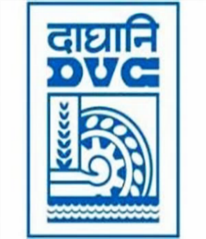
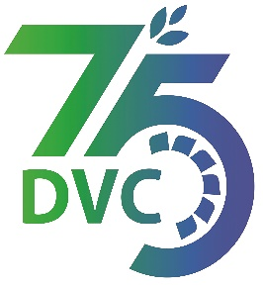
damaooadr GaaTI inagama
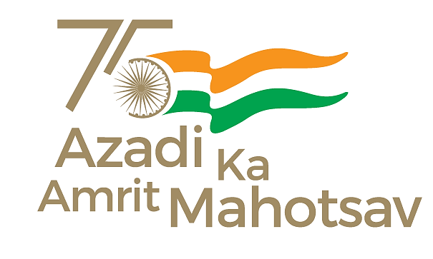
Damodar Valley Corporation
संविदा और सामग्री विभाग
Contracts and Materials Department
डीवीसी टावर्स; तृतीय तल; वीआइपी रोड; कोलकाता-७०००५४ टेली फ़ैक्स न०-०३३-२३५५-२९३६
DVC Towers; 3rd Floor; VIP Road, Kolkata – 700054 Tele fax No.-033 – 2355 –2936.

E-Tender Notice

Damodar Valley Corporation invites online bids (Open Tender with E-Reverse Auction) from the eligible bidders for:

REFERENCE NO. | Description of item | Tender Downloading Period and Time
DVC NIT NO:- DVC/Tender/Head Quarter/SPE/CMM/Works and Service/00064/Capital dated 19/04/2024. ***************************  CPP Tender ID:- 2024_DVC_190455_1 | SUPPLY, ERECTION, TESTING & COMMISSIONING WORKS FOR REPLACEMENT OF EXISTING ACSR LARK/PANTHER CONDUCTOR IN RESPECT OF 132 KV D/C TRANSMISSION LINES OF DVC WITH AAAC PANTHER CONDUCTOR | From:  19.04.2024 at 18.00 Hrs.(IST)  to  17.05.2024 at 12.00 Hrs.(IST)

For further details and to participate in tender, please log on:
https://etenders.gov.in/eprocure/app

Note: For any Technical Queries call:- 0120-4200 462, 0120-4001 002, 0120-4001 005,
0120-6277 787.

E-Mail Support: Technical - support-eproc(at)nic(dot)in

